**Name :** Syed Ali Fathima M

**Email :** [fathimamusthakali@gmail.com](mailto:fathimamusthakali@gmail.com)

**Reg.No :** 731621121055

**SQL LAB PRACTICE -01:**

**(07/08/2024)**

**Qn:**

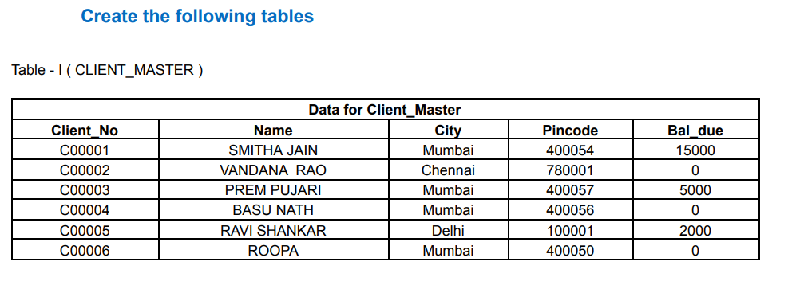

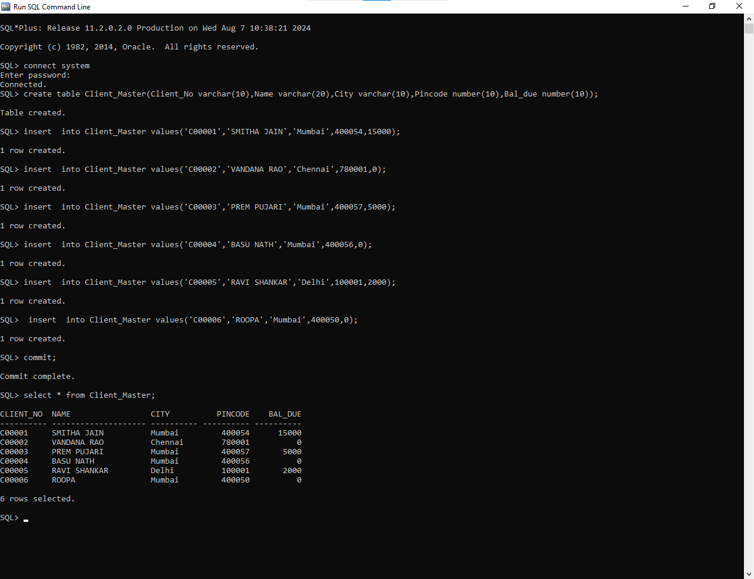**Sql commands :**

**Qn:**

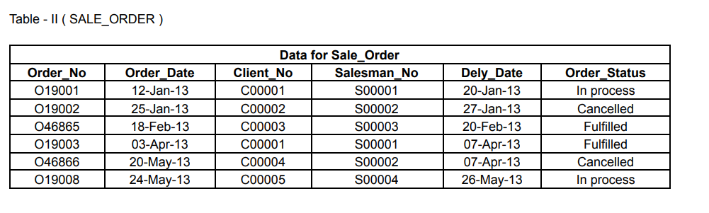

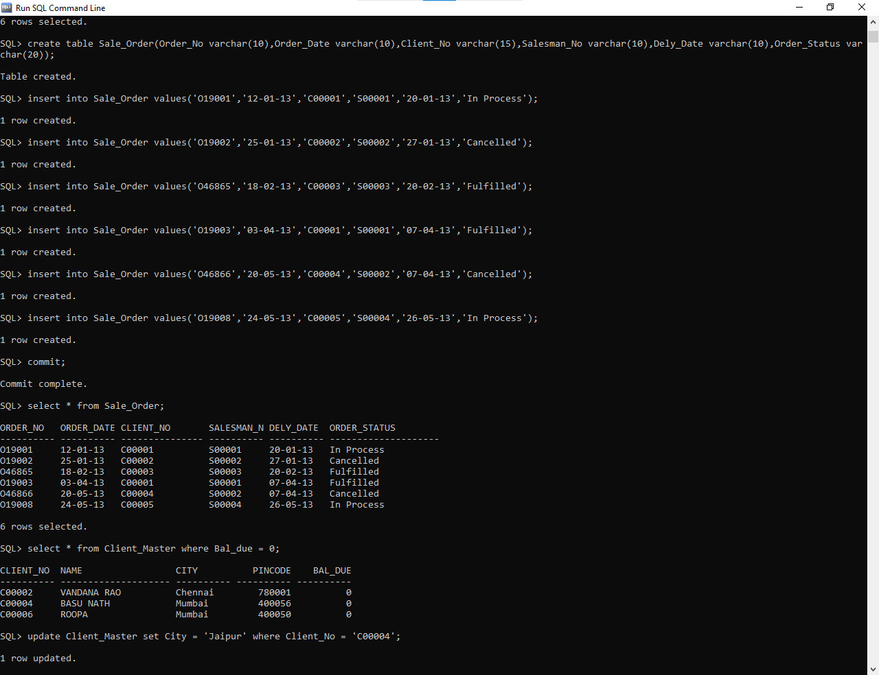**Sql commands:**







